**Executive Summary: The Water Crisis**

The purpose of this research is to investigate the relationship between poverty and clean water accessibility in order to develop sustainable solutions to the global water crisis.

Poverty affects both the individual and society as a whole. Some indirect consequences are:

* Disease transmission
* Resource conflicts and crime
* Social tension
* Monetary cost of aid, welfare, and food stamps

Water is both the cause and solution of poverty:

* Dehydration and water borne illness compromise an individual’s ability to function
* The inability to work restricts an individual’s opportunity to generate income
* The water poverty trap stems from this self-perpetuating series of events
* Access to clean water allows the time previously spent acquiring and purifying water to be spent on work, education and infrastructure

In the United States:

* Lack of clean water resources and cleanliness are environmental issues or consequences of poverty
* Water contamination affects both the poor and the wealthy

In Ethiopia:

* Lack of access to clean water is one element of the poverty trap
* The water crisis is a generational problem

Solutions:

* Solar powered wells, hand dug wells, drilled wells
* Spring protectors
* Rainwater catchments and gravity fed systems
* Life straw
* Increased government legislation
* Upgrade pipes and sewer systems to more eco-friendly and efficient ones
* Construct a school that educates household matriarchs in becoming water sanitation engineers

The College of New Jersey

The Water Crisis

Water Availability, Impact, and Solutions in the United States and Ethiopia

Kaelyn DiGiamarino, Bryan Guner, Oreoluwa Nubi

FSP 124:04 Eradicate Poverty

Dr. Karen Becker

December 10, 2014

ABSTRACT

Second only to oxygen, water is the most basic necessity of survival. In order to free the poor from the poverty trap, governments need to provide access to clean drinking water. A multilateral approach must be chosen in order to address the various obstacles. The first step in providing Ethiopia with accessible drinking water is to address the government corruption. The best way to solve this dilemma on a national level is to first bring it down to a personal level. A department of transparency responsible for collecting complaints, generating statistics, and exposing the individuals responsible for corruption to the public and media must be established. In the case of Ethiopia, the government and private sector lack the technical know-how and logistical capability to solve the nation’s water issues. Our solution is to establish a school for Ethiopian matriarchs. Women who attend this school will be trained as sanitization engineers, as inspired by the Barefoot College. This enables the women to provide a valuable service while establishing a career for themselves. Governments, companies, and people are reluctant to give their time and money to a cause that they do not directly see a gain from. The long-term effects of poverty on a society are far more costly than the costs of eradicating it. When viewed from a holistic perspective, fixing poverty becomes something society should do for themselves, rather than a moral obligation.

Key words: Poverty, corruption, sanitization engineers, water, Ethiopia

Table of Contents

I. Introduction

a. Poverty’s Effect on Society……………………………………………………………..6

II. The Importance of Water

a. Water as a Necessity …………………………………………………………………...6

b. Problems Associated with Lack of Water………………………………………………7

c. Water’s Effect on Poverty………………………………………………………………8

III. The United States versus Ethiopia

a. The United States……………………………………………………………………….9

b. Ethiopia………………………………………………………………………………..10

c. The Difference………………………………………………………………………...12

IV. Non-governmental Organizations Taking Action

a. Charity: Water…………………………………………………………………………13

b. WaterAid………………………………………………………………………………14

c. The Water Project……………………………………………………………………..15

V. Solutions

a. Solution Options………………………………………………………………………15

b. The United States’ Solutions…………………………………………………………16

c. Ethiopia’s Solutions…………………………………………………………………...17

d. Our Solution…………………………………………………………………………...18

VI. Concluding Remarks………………………………………………………………………...19

VII. Appendix……………………………………………………………………………………20

The Water Crisis

"Thousands have lived without love, not one without water" (Wystan Hugh Auden). When a person is asked if they need anything, they almost always think of material items that they want. If this question were meant to be literal, the response would be oxygen, water and food, shelter, and sleep. Wystan Auden makes use of literalism to portray the importance society places on love. In reality, the importance should be placed on human necessities, such as water. This witticism was not intended to ridicule people’s craving for love and acceptance. Rather, its purpose was to draw attention to basic human necessities that are forgotten in first world society. In developed countries, individuals spend most of their lives in the pursuit of desires and have forgotten what it means to survive. Inhabitants of these nations do not merely “survive”. Instead, technological innovation and economical stability allows the people of developed nations, such as the United States, to live a lifestyle that does not involve prioritizing biological needs. While having a profitable career, a house with a white picket fence, and a two-child family are staples of American culture, they are not in fact needs. A true “need” is water. Without water, bodily functions are quickly compromised. Dehydration limits an individual’s ability to function; therefore they cannot work. The inability to work restricts the opportunity to generate income. Income allows a person to purchase and obtain the sustenance necessary to stay in working condition. The water poverty trap stems from this self-perpetuating series of events and is prevalent in developing nations, where people face water scarcity and contamination daily.

*a. Poverty’s Effect on Society*

Not only does poverty have a direct effect on the impoverished, but society as a whole also suffers from its externalities. These externalities include disease transmission, resource conflicts, crime, social tension, and the monetary cost of aid that society pays for.

Impoverished communities are repeatedly plagued with disease. The lack of proper health conditions, clean water, and access to medicine create an environment where disease thrives. It is common for epidemics to begin in impoverished areas with poor sanitation.

The scarcity of resources in under-developed nations leads to an increased number of conflicts. There are a finite number of resources, but an infinite number of people in need of them. For this reason, community members resort to fighting in order to obtain these resources. The more economically unstable an area is, the more crime rates escalate.

Additionally, there is a widening gap between the poor and the wealthy. This creates social tension among classes. Income inequality results from a country’s wealth being inadequately distributed between its citizens. Strikes and riots are common in countries with large divisions between their socioeconomic classes.

Members of the upper and middle classes also pay the price of funding the remedies given to the impoverished. For example, in the United States, the money used for welfare and food stamps comes directly from the taxes of American citizens.

**II. THE IMPORTANCE OF WATER**

*a. Water as a Necessity*

The human body is approximately 65% water (waterproject.org). Water carries nutrients to cells, disposes of waste, and is the main catalyst in digestion. Additionally, it is the primary component of the electrolyte solutions of the body’s nervous system. Water is used to conduct electro-neural impulses and is crucial to the distribution and regulation of body heat (rochester.edu). Without water, not a single part of the body can function.

*b. Problems Associated with Lack of Water*

The most serious consequence associated with immediate lack of water is dehydration. Dehydration occurs in multiple stages. The first is when 1% of water weight is lost, at which point physical and cognitive abilities are mildly impaired, accompanied by dry-mouth and reduced urination. The next stage occurs when 2-4% of water weight is lost. At this point, victims suffer sunken eyes, dry skin, increased heart rate, and lethargy. When more than 10% of water weight is lost, the victim suffers intense migraines, organ failure and finally, death (waterproject.org). Death due to dehydration occurs after three consecutive days without fluids. While it may take three days to die, it only takes one day of dehydration to become incapacitated to the extent of not being able to work. The resulting lack of income keeps them from acquiring resources they need to survive. This vicious cycle is known as the water poverty trap. Not only does the poverty trap directly affect the poor, but also their respective economies and governments who suffer the weight of providing for a society that is not self-sufficient.

However, dehydration is not the only concern when it comes to water. There are many diseases that can be contracted through contaminated water. Cholera, hepatitis and typhoid fever are bacterial diseases that can be transmitted directly through drinking unpurified water. Other parasitic diseases such as dysentery and malaria are also linked to unclean water, but are transmitted indirectly via a host. For example, malaria is contracted from mosquitos that thrive in stagnant unsanitary water. 783 million people across the globe lack access to clean water, which is why water borne illnesses account for the largest cause of death worldwide (sciencedirect.com).

*c. Water’s Effect on Poverty*

Challenges associated with water scarcity and unclean water have serious implications. People of rural villages constitute 84% of those who do not have access to clean water (sciencemag.org). The large distances between villages provide logistical obstacles to obtaining safe drinking water. The least obvious of all consequences, is lost time. Water sources are typically located many miles away from the impoverished rural villages they sustain. Girls under the age of 15 are twice as likely to be tasked with fetching water, a chore that can take up to four hours per day and entails carrying 40-pound jugs (thewaterproject.org). The time constraints associated with collecting water prevent children from attending school, parents from holding jobs, and matriarchs from raising their families.

Every year, water borne illness is the cause of 433 million missed school days, half of all hospital admissions globally, and 3.4 million deaths (voanews.com). Water borne illnesses are also responsible for 20% of the deaths of children under the age of five, and roughly 80% of all illnesses in developing countries (thewaterproject.org). 66% of people in sub-Saharan Africa lack access to a toilet, and 50% of primary schools lack even the most primitive forms of plumbing (WHO.int). The lack of school plumbing forces many female students to drop out when they reach puberty because their female hygiene needs cannot be met.

These statistics illustrate the failure of governments to address corruption internally. In developed countries like the United States, water sanitization is a negligible fraction of governmental spending. The real hurdle is holding a government accountable to make the necessary changes and educate sanitization engineers who are charged with implementing sustainable solutions.

**III. THE UNITED STATES VERSUS ETHIOPIA**

*a. The United States*

The United States has a population of 316.1 million people (census.gov); of these people, 80% are urbanized (unicef.org). People in the United States predominantly make a living through jobs in manufacturing, health service, education, wholesale and retail trade, and government. The geographic location of the United States is one with varied topography and mostly temperate weather. Although the United States is involved in conflict with other countries, those conflicts take place overseas. There is no warfare within the borders of the United States. Due to the urbanized population, the variety of available jobs, and favorable geographic location, the majority of Americans live above the poverty line. The number of Americans that do live below the poverty line, 13.6%, is still larger than it should be (surface.syr.edu). However, the United States has nowhere near the high poverty level of under-developed countries.

Just like the poverty level, the water crisis in the United States is not as pressing as it is in developing countries. Nonetheless, the issue still exists. Environmental issues chiefly impede the water quality in the United States; examples of this are high chemical corrosion, fracking, and chemical spills. Moreover, rusty pipes and the inability of some individuals to pay a water bill are also issues that cause lack of water resources and cleanliness.

The effect of the United States’ water problems can be seen in East Orosi, California. Here, it is a struggle to find clean drinking water. The tap water is a risk to drink, as it contains nitrates that can cause “blue baby syndrome”, a potentially fatal blood disorder that cuts off an infant’s oxygen supply. The town is made up of mostly low-income Latinos, and more than half live below the poverty line (scientificamerican.com). There is a sense of neglect in the air. With no sidewalks, streetlights, parks, or playgrounds it seems as if the town has been forgotten. Furthermore, the residents pay for the tap water that is not fit to drink.

This environmental justice problem is not unique to East Orosi. Of eight counties in the San Joaquin Valley, approximately 5,200 people had drinking water that surpassed federal nitrate standards. It is not infrequent that water systems in this area of California repeatedly exceed safe levels of coliform bacteria, nitrates, or arsenic. Nitrates are byproducts of unclean farming practices. Nitrogen is found in synthetic fertilizers, animal manure, septic tanks, and wastewater treatment plants. Use of these products lead to contaminated water supplies. According to the University of California, agriculture is the reason for 96% of water contamination in these areas (scientificamerican.com).

This contamination affects both the poor and the wealthy. However, the wealthy have resources that give them the mobility to avoid the situational problem. The rich are able to move to a new town, rent a hotel to stay at, or travel to stay with family. The poor do not have these resources, and are left with no other choice but to stay in their contaminated town. This contamination problem has been going on for years. Once the majority of the wealthy families have moved out of the area, only the poor are left.

*b. Ethiopia*

On the other end of the spectrum is Ethiopia. Ethiopia is a country located in the Horn of Africa and has a population of 91,730,000 (charitywater.org). Ethiopia has faced famine, drought, political instability, and war throughout its history. Although peace has returned, the nation still remains weak both developmentally and in its infrastructure. 43.4 million people in Ethiopia—over half of the population—do not have access to safe water, and over 67 million people do not have access to adequate sanitation (wateraid.org). Due to its geographic location, Ethiopia faces extended periods of droughts, famines, and conflicts. These obstacles seriously impact the health and life expectancy of the country’s citizens. It is likely for a child in Ethiopia to die before the age of five.

29.6% of Ethiopians live below the poverty line, a percentage largely due to the water crisis (worldbank.org). Most people in Ethiopia make a living through farming, a task they cannot perform without water to grow the crops. In addition to droughts, challenges also arise through low water tables and roads in poor condition that make it difficult to reach remote villages. The majority of rural families in Ethiopia survive on less than five liters of water per day, which they have to walk up to four hours to collect. An entire family must share this meager amount of water to hydrate and bathe each individual, wash dishes and laundry, feed livestock, and sustain farming.

Personal stories reflect the severity of Ethiopia’s water crisis. Hadis Tekele is a 63-year-old priest living in Asegeda, Ethiopia, where rainfall is close to non-existent in the months of September through June. The only water available to the small community is located two miles away at a hand pump installed by the local government, accessible only by an hour-long trip on foot. Collecting water is extremely time-consuming—time that could be spent more productively elsewhere. Hadis, a member of the community’s sanitation committee, explained, “If we had water nearer our houses, we will have more time for different activities such as farming” (wateraid.org). Due to lack of easy access to water, the people of Asegeda use what little water they can collect for drinking. They have no surplus to use towards their personal cleanliness or health. With no water to grow crops, a person that relies heavily on their agriculture to make a living will have no way to feed or support his or her family. The people of Asegeda, Ethiopia are trapped in poverty by this unquenchable thirst.

The water crisis in Ethiopia is a part of the poverty trap and it is a generational problem. When a child is born into a community highly populated with families with limited resources, upward intergenerational mobility—an individual’s transition to a social class above his or her parents—is very difficult, if not impossible.

The country of Ethiopia relies heavily on agriculture. Agriculture accounts for 41% of Ethiopia’s gross domestic product, 80% of exports, and 80% of the labor force (tradingeconomics.com). It is impossible to farm without water. The limited availability of clean water restricts potential profit from agriculture. This is why the water crisis in Ethiopia not only affects each individual citizen, but also the country as a whole.

*c. The Difference*

There is a stark contrast between the water crisis in the United States, a developed urbanized country, versus Ethiopia, an undeveloped rural country. The difference is well defined when the countries’ life expectancies are compared against their improved water sources. Using GapMinder, these two factors can be matched on a scatter plot graph, as seen in Figure A, found in the appendix. The United States is in the upper right hand corner of the graph. The country had an improved water source of almost 100%, and a high life expectancy of 75 to 80 years of age in the year of 2002 (gapminder.org).

Ethiopia is plotted on the left hand, upper third of the graph. The percent of improved water sources falls short at only 30-35%. The life expectancy of citizens in the country was only about 50-55 years of age (gapminder.org). Ethiopia was in close company with the remaining countries of sub-Saharan Africa, who fell in the same part of the graph. There is a definitive line between the sub-Saharan African countries and the rest of the globe. The trend of the graph reveals a close correlation between clean water and the long-term health of an individual.

Another correlation can be found when looking specifically at diarrheal deaths in relation to improved water sources. Diarrhea is a very preventable illness, and is a consequence of drinking unclean water. It is logical that a country with less access to clean water will have more cases of diarrhea.

It is common for Ethiopian children to die before they reach the age of five. A large number of these deaths are due to diarrhea. According to GapMinder, in 2008 there were almost 100,000 diarrheal deaths of children ages 1-59 months old in Ethiopia. In comparison, there were about 50 diarrheal deaths of children in the same age range in the United States (gapminder.org). See Figure B in appendix for this graph.

In the United States the water crisis is a consequence of poverty, whereas in Ethiopia it is just one element of the poverty trap. Because the water crisis in the United States differs from the water crisis in Ethiopia, the solution needed is also different. There is no “one size fits all” solution to a water crisis.

**IV. NON-GOVERNMENTAL ORGANIZATIONS TAKING ACTION**

*a. Charity: Water*

Charity: Water is a non-profit organization that brings safe, clean drinking water to communities in developing nations. 100% of public donations given to this non-governmental organization (NGO) are used to fund its water projects (charitywater.org). Private donors, foundations, and sponsors cover the organization’s operation costs. To ensure that donations are directly helping the projects that the money is intended for, the organization has established Dollars to Projects. Dollars to Projects allows donors to know exactly what their money is being used for (charitywater.org). Two years after each project is initiated, photos and GPS systems are used to show the progress that has been made in the community receiving aid.

Charity: Water works with partners to ensure that projects are long lasting. It is guaranteed that each water project abides by the community’s preferences. The community is involved in the decision process and it is their specific preference of technology that is ultimately used (charitywater.org). For example, some communities may not be comfortable with the machines that drill wells. Thus, hand dug wells would be a better option for them.

*b. WaterAid*

Another NGO is WaterAid. WaterAid works internationally to bring safe water and proper sanitation practices to communities. They believe that safe water leads to better health, education, and livelihoods (wateraid.org).

The four global aims of WaterAid are:

1. To promote and secure rights and access to safe water, improved hygiene, and sanitation for those that cannot fight for it themselves
2. To support governments and service providers in developing their capacity to deliver safe water, improved hygiene, and sanitation
3. To advocate for the essential role of safe water, improved hygiene, and sanitation in human development
4. To further develop as an effective global organization recognized as a leader in WaterAid’s field and for living WaterAid’s values (wateraid.org).

These aims consider the importance of government in the success of a project, especially regarding water. WaterAid believes that changing policy and normal practices will improve the state of water and sanitation in each community (wateraid.org). WaterAid looks at local issues in order to meet the exact need of a specific community. They help local and international communities set up practical and sustainable projects that will continue to provide clean water for years to come.

*c. The Water Project*

The Water Project is a NGO that works with sub-Saharan countries. They believe that their team members can “grow and learn” by being physically involved in the projects, taking risks, making mistakes, and listening (thewaterproject.org). The Water Project’s team members do hands-on work. They have the opportunity to get involved with the communities being aided and gain a new perspective in return.

The Water Project believes that clean water gives hope and unlocks human potential. Funds given to this NGO are administered to projects such as drilled wells, sand dams, rainwater catchments, hygiene and sanitation, and spring protection.

**V. SOLUTIONS**

*a. Solution Options*

Solutions to provide communities with fresh water are abundant and come in various forms. One solution involves tapping into the earth to dig a well. Wells can either be hand dug or drilled, both of which reach fresh aquifers below the ground. Construction of solar powered water wells is an environmentally friendly option. The system pumps water out of a water source, purifies it, and sends it to the local village. This effectively creates running water in areas without strong infrastructure and does not require the human labor of traditional pumps. Piped systems are networks of pipes that supply water to different community tap stands. Spring protectors are systems that capture and safely store pure water from a natural spring. Taking advantage of rainfall is another possibility. Through rainwater catchments and gravity fed systems, rainfall can be collected and stored in a sanitary holding tank.

The Life Straw is a water purifier option that is already in use. It has also proven to be profitable. This straw requires no electrical power, batteries, replacement parts, running water, or piped-in water supply. The Life Straw has an easy to clean pre-filter and purification cartridge that removes bacteria, viruses, and protozoan parasites found in water (lifestraw.org).

*b. United States’ Solutions*

Solutions to fix the United States’ water issues are not as extensive and difficult compared to those of developing countries. The United States needs to upgrade its pipes and sewer systems to ones that are more eco-friendly and efficient. For example, in New Jersey there are old urban areas that have pipes dating back to the nineteenth century (NJfuture.org). More government legislation, such as the Clean Water Act, must be passed to ensure clean water in the United States. The Clean Water Act “establishes the basic structure for regulating discharges of pollutants into the waters of the United States and regulating quality standards for surface waters” (EPA.gov). Pollution control programs such as the Environmental Protection Agency can help to improve the water standard and ensure pollution control.

The Environmental Protection Agency (EPA) is responsible for enforcing the Clean Water Act (CWA). The CWA establishes certain water quality standards and these standards define the operations that will be completed. They determine what water will be cleaned and what pollution will be discharged. The EPA reviews and revises the standards, creates new standards if needed, and provides technology to develop them (EPA.gov).

*c. Ethiopia’s Solutions*

Government corruption is one of many causes of poverty in developing countries. Specifically pertaining to water, corruption is rampant and extensive. Corrupt officials are pocketing funds that are meant to fix water issues. Projects for water management, irrigation, and dams are costly and therefore targets of greedy officials. Despite the fact that Ethiopia is one of the fastest-growing economies in Africa, it is still one of the world’s poorest countries. Corruption is one of the causes of this disparity (transparency.org).

To fight this corruption, the Federal Ethics and Anti-Corruption Commission (FEAC) was created in Ethiopia. Their mission is to

“Ensure that the country's resources go to the desired development projects by expanding ethics and anti-corruption education; examining the practices and working procedures in federal public offices and enterprises and thereby plugging loopholes that are believed to be conducive for corruption; exposing, investigating and prosecuting alleged corruption offences where they are committed in federal public offices and public enterprises, or in the regional offices related to subsidies granted by the Federal Government” (FEAC).

The FEAC takes action to better the government and to ensure that funds are appropriated to the right place. Furthermore, in the book *Designing A World That Works For All,* by Medard Gabel, William Sheehan describes a government solution called Waterment. Waterment is a government agency that initiates laws and regulations for water usage in the home, industry, and agriculture. The main focus is water conservation. Since Ethiopia frequently struggles with drought, the best option is to begin with water conservation. Additionally, Waterment ensures that clean water will be provided to all people. The Waterment strategy makes use of the Kisii Water Filter. The Kisii Water Filter is an economical filter that removes most bacteria from local wells and aids in their preservation. The water crisis will only be resolved when the government enforces strategies to help provide clean, accessible water to communities that need it.

*d. Our Solution*

The United States solution is relatively simple compared to the Ethiopian solution. The United States needs to continue to use the EPA to enforce the CWA. The United States must consider passing more laws in order to ensure clean water practices. American water will only be cleaner if higher water standards are set. Pollution control and higher water standards will positively contribute to the United States’ clean environment initiative.

In Ethiopia, the first step to better water is to fight corruption. The water in Ethiopia will improve when funds are appropriated to the water projects, and not to the pockets of corrupt government officials. The government needs to work alongside NGO initiated projects. This will result in the water projects being more successful.

Once government corruption is addressed, improved water conservation tactics must be implemented. Ethiopia is frequently hindered by droughts that cause severe water shortages. One precautionary measure is a rain catchment system with sanitary water storage. This should be put in place to avoid the impact of a period of drought.

The last aspect to our solution is the Barefoot College approach. The Barefoot College is located in India and is very successful. It teaches women in developing countries professional skills that they can use in their communities. The Indian women are taught to be solar power engineers and are able to use that knowledge to bring electricity, hot water, solar cookers, and fresh water to their village (barefootcollege.org).

An approach of this type would not only empower women in Ethiopia, but also provide necessary help for the country to overcome its water crisis. The Ethiopian project needs to produce water sanitation engineers. Like the graduates of India’s Barefoot College, the educated Ethiopian women could have the power to help engineer and build solar powered wells in their respective communities.

**VI. CONCLUDING REMARKS**

The global water crisis is a problem that affects both the wealthy and the poor, albeit in different ways. Short-term effects of a lack of water include dehydration and a decrease in productivity. The short-term consequences of unclean water are water-borne illnesses. Rampant corruption, short life expectancy, and generational poverty are all long-term results of the water crisis. Because the water crisis impacts different communities in different ways, a variety of solutions are needed. Solutions must be sustainable and address the issue head-on. All corruption, pollution, and other obstacles in the way of clean water availability must be tackled before there can be growth.

**VII. APPENDIX**

Figure A: Life Expectancy vs. Improved Water Sources

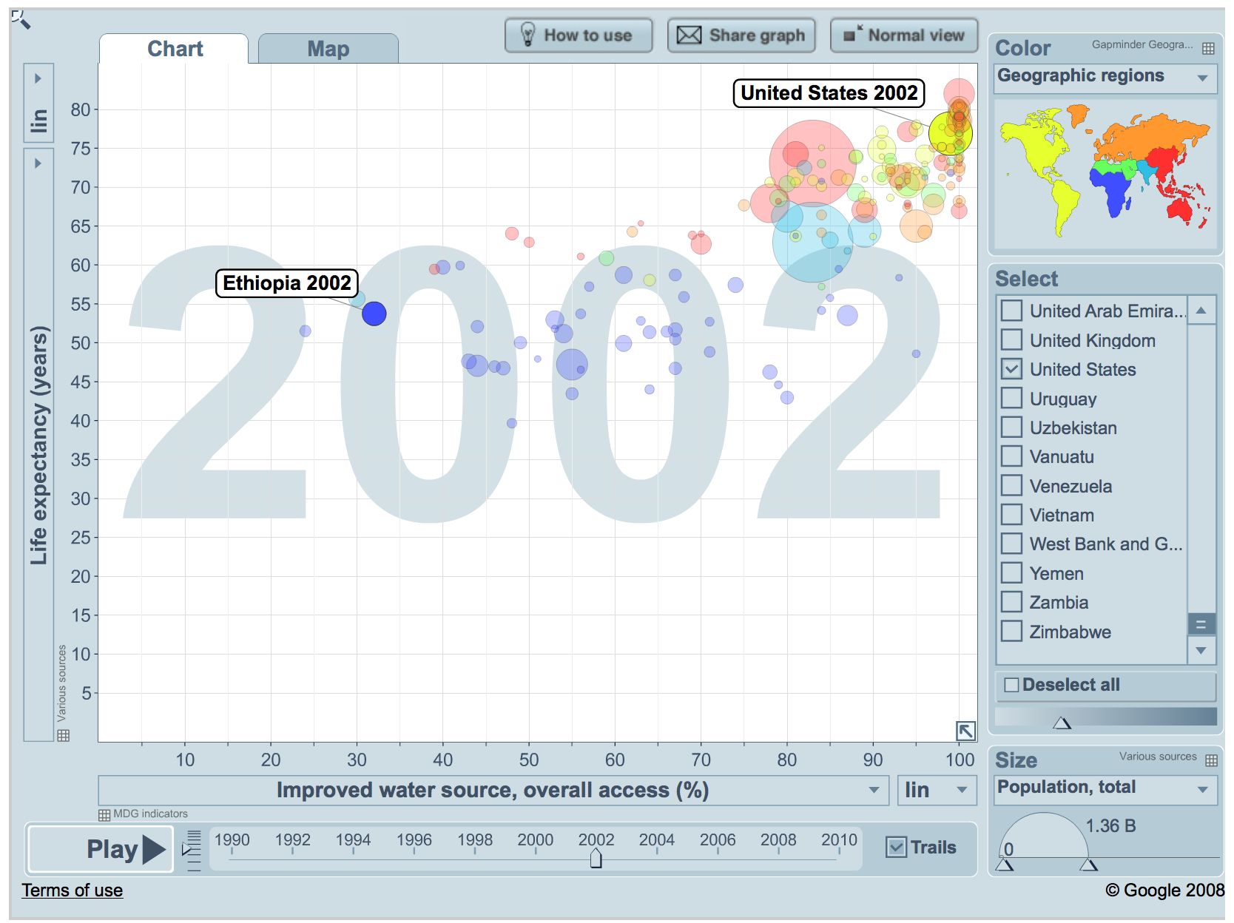  
www.gapminder.org

Figure B: Diarrheal Deaths in Children 1-59 Months vs. Improved Water Sources

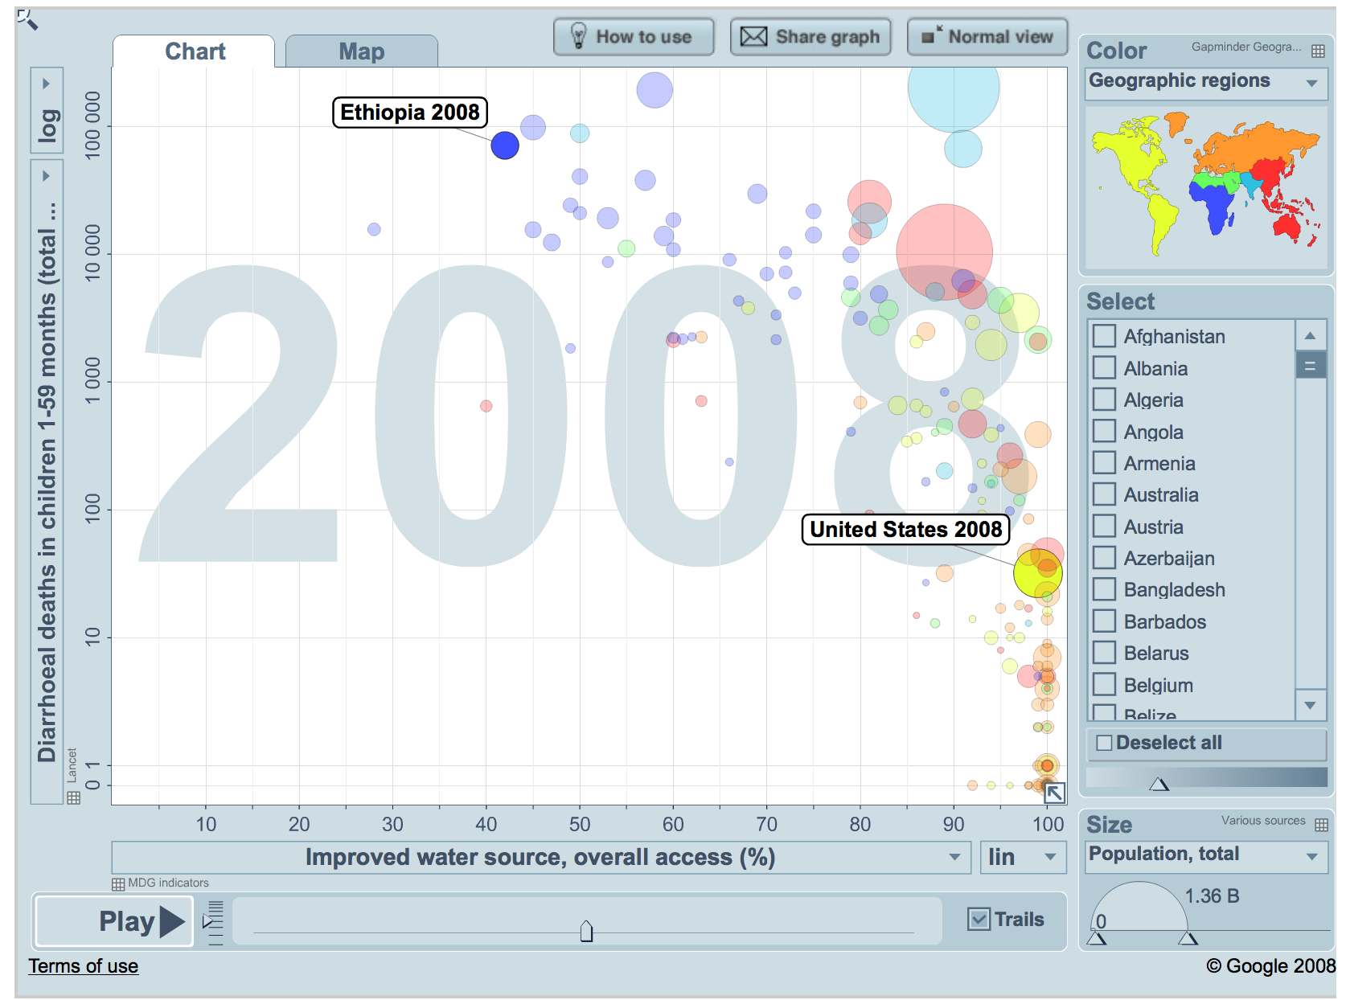

www.gapminder.org

Works Cited

Berman, Jessica. "WHO: Waterborne Disease Is World's Leading Killer." *VOA*. Voices Of America, 29 Oct. 2009. Web. 08 Dec. 2014.

"Ethiopia." *Data*. World Bank. n.d. Web. 29 Nov. 2014. <http://data.worldbank.org/country/ethiopia>.

"Ethiopia GDP 1981-2014." *Ethiopia GDP*. Trading Economics. n.d. Web. 21 Nov. 2014. <http://www.tradingeconomics.com/ethiopia/gdp>.

*Federal Ethics and Anti-Corruprion Commission*. N.p., n.d. Web. 5 Dec. 2014. <http://www.feac.gov.et>.

Gabel, Medard. *William Sheehan*. *Designing a World That Works For All*. 4th ed. Media, PA: Gabel Graphics, 2014. N. pag. Print.

"Improved Water Source." *Data*. World Bank. n.d. Web. 18 Nov. 2014. <http://data.worldbank.org/indicator/SH.H2O.SAFE.ZS>.

Lewis, Lori. "Water In Crisis - Spotlight Africa: Rural and Urban Issues." *The Water Project.org*. The Water Project, n.d. Web. 09 Oct. 2014.

"LifeStraw... It's Life." *LifeStraw.org.uk*. Life Straw, n.d. Web. 12 Nov. 2014.

"Pollution, Poverty and People of Color: Don't Drink the Water." *Scientific American Global RSS*. n.d. Web. 29 Nov. 2014. <http://www.scientificamerican.com/article/pollution-poverty-people-color-dont-drink-water/>.

"Share Graph." *Gapminder*. N.p., n.d. Web. 29 Nov. 2014. <http://www.gapminder.org/world>.

Smeeding, Timothy; Rainwater, Lee; and Burtles, Gary, "United States Poverty in a Cross-National Context" (2001). *Center for Policy Research.* Paper 151.

<http://surface.syr.edu/cpr/151>

“Solutions." *Charity: Water*. n.d. Web. 30 Oct. 2014. <http://www.charitywater.org/projects/solutions/>.

Sturm, Chris. "New Report Highlights State’s Water Infrastructure Crisis." *New Jersey Future*. Web. 9 Dec. 2014.

Sullivan, Caroline. "Download PDFs." *Calculating a Water Poverty Index*. Science Direct, 19 Apr. 2002. Web. 10 Oct. 2014

"Transparency International - The Global Anti-Corruption Coalition." *Transparency International - The Global Anti-Corruption Coalition*. N.p., n.d. Web. 2 Dec. 2014. <http://www.transparency.org/>.

"UNICEF - SOWC05." *UNICEF*. Web. 15 Sept. 2014. <http://www.unicef.org/sowc05/english/statistics.html>.

"United States Census Bureau." *About Population Estimates*. N.p., n.d. Web. 17 Nov. 2014. <<http://www.census.gov/popest/about/terms.html>>.

"US Environmental Protection Agency." *EPA*. Environmental Protection Agency, n.d. Web. 04 Dec. 2014. <http://www.epa.gov/>.

Vorosmarty, Charles, Pamela Green, Joseph Sailsbury, and Richard Lammers. "Global Water Resources: Vulnerability from Climate Change and Population Growth." *Science Magazine: Sign In*. Science, 14 July 2000. Web. 09 Oct. 2014.

Waititu, Earnest. "Africa's Growing Water Crisis." *PBS*. org, n.d. Web. 09 Oct. 2014

"WaterAid America - Clean Water & Sanitation for Africa, Asia & Central America." *WaterAid America - Clean Water & Sanitation for Africa, Asia & Central America*. Water Aid. n.d. Web. 29 Nov. 2014. <http://www.wateraid.org/us/>.

"Water Wars." *Pulitzer Center on Crisis Reporting*. Pulitzer Center.org, 12 Jan. 2008. Web. 10 Oct. 2014.